# SHEET -12– PACKAGE MANAGEMENT – RPM

.rpm is the package name and tools to manage the package is yum/dnf and rpm

**Become root before doing this exercise**

1. List all the installed rpm packages
   1. rpm -qa | more

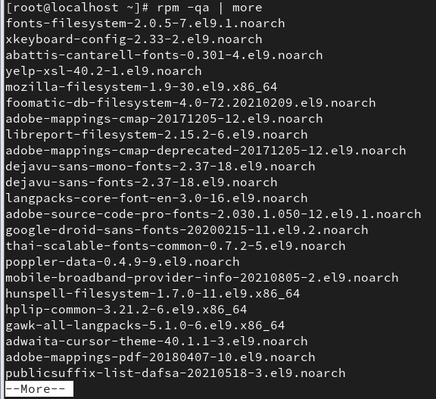

* 1. rpmquery -a | more

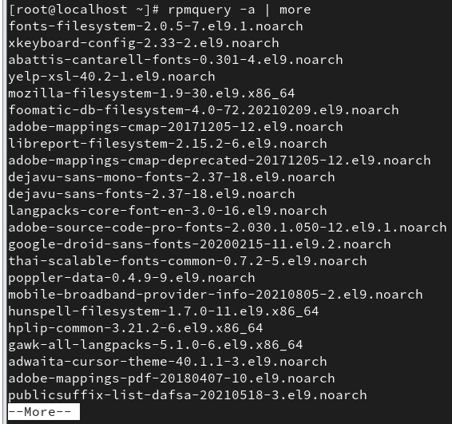

* 1. rpm -qa | wc -l

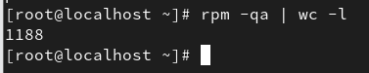

* 1. rpmquery -a | wc -l

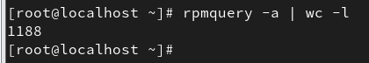

* 1. rpm -qa --last

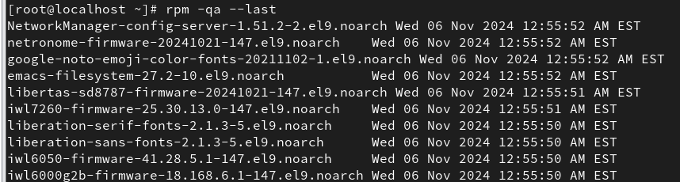

1. Check whether acl ,shadow-utils,passwd,firewalld package is installed
   1. rpm -qa acl

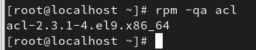

* 1. rpm -qa | grep acl

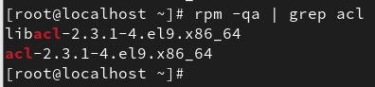

* 1. rpmquery acl

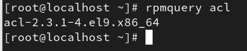

* 1. rpmquery -a | grep acl

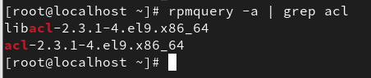

* 1. rpm -q acl



1. Repeat the 2.a –e for shadow-utils,passwd and firewalld
2. Install vsftpd package
   1. Download the package from internet ([vsftpd-3.0.3-49.el9.x86_64.rpm CentOS 9](https://centos.pkgs.org/9-stream/centos-appstream-x86_64/vsftpd-3.0.3-49.el9.x86_64.rpm.html)

[Stream Download (pkgs.org))](https://centos.pkgs.org/9-stream/centos-appstream-x86_64/vsftpd-3.0.3-49.el9.x86_64.rpm.html)

* 1. Install using rpm -ivh vsftpd…..rpm

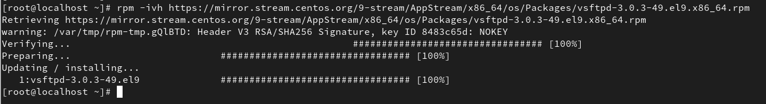

1. Download Apache server – httpd package and before installing
   1. Check for dependencies using – rpm -qRp packagename

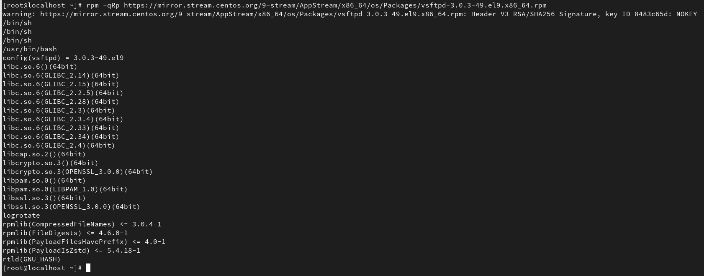

* 1. Get info abt the package using – rpm -qip packagename

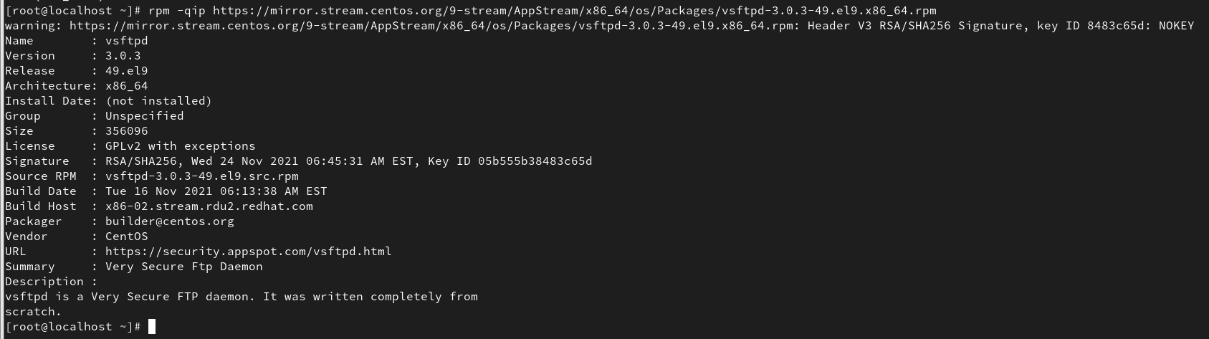

* 1. Get the config files using – rpm -qcp packagename

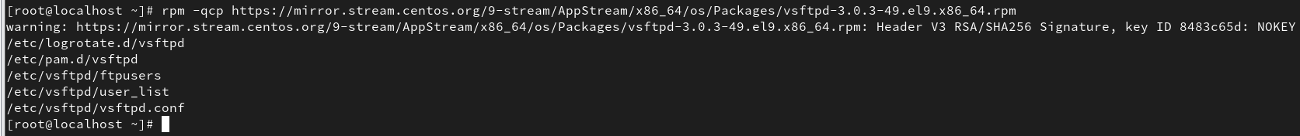

* 1. Get the docs using -rpm -qdp packagename

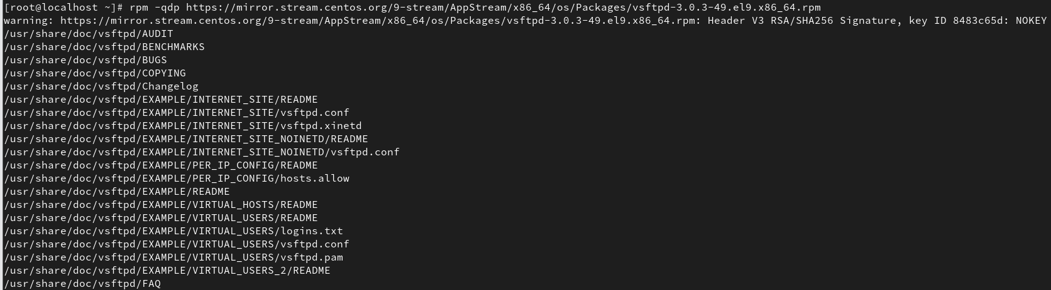

1. Install httpd package
2. List all files of the package using – rpm -ql vsftpd

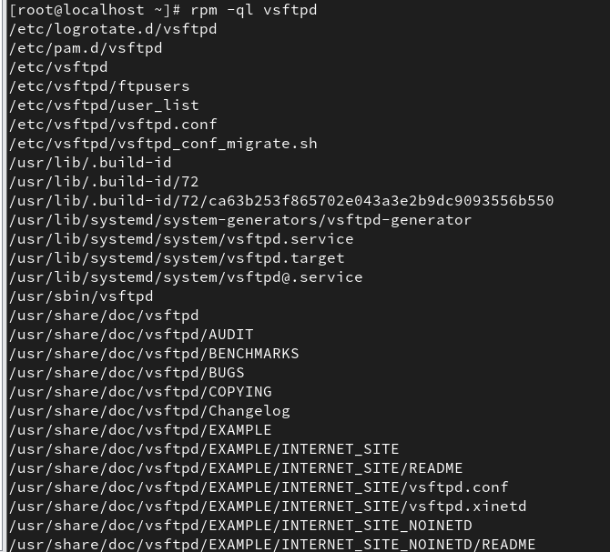

1. Upgrade an rpm package using – rpm -Uvh packagename

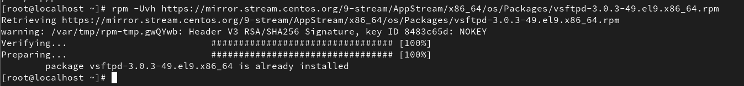

1

# SHEET -12– PACKAGE MANAGEMENT – RPM

1. Get info about the installed rpm package using rpm -qi packagename

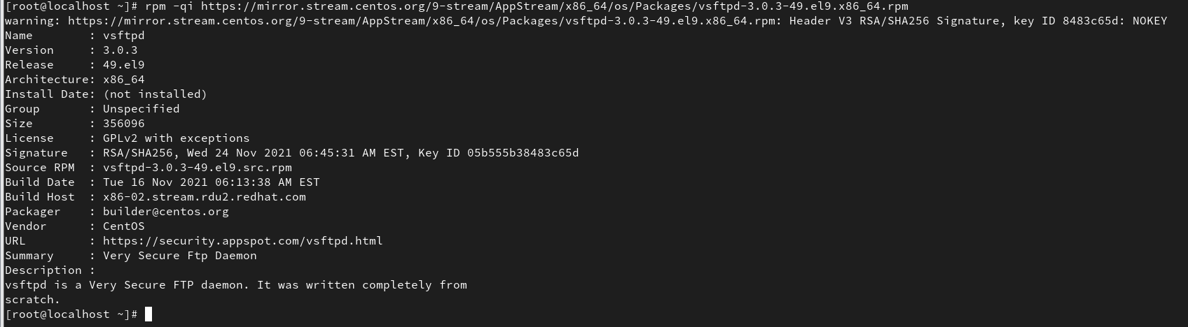

1. Query the files that belongs to which rpm package
   1. rpm -qf /usr/sbin/useradd
   2. rpm -qf /etc/vsftpd
   3. rpm -qf /usr/bin/passwd
   4. rpm -qf /usr/bin/getfacl

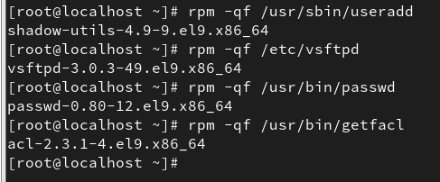

1. List the doc and config files of the installed packages
   1. rpm -qcf /usr/bin/passwd
   2. rpm -qdf /usr/bin/passwd
   3. rpm -qcf or -qdf /etc/vsftpd

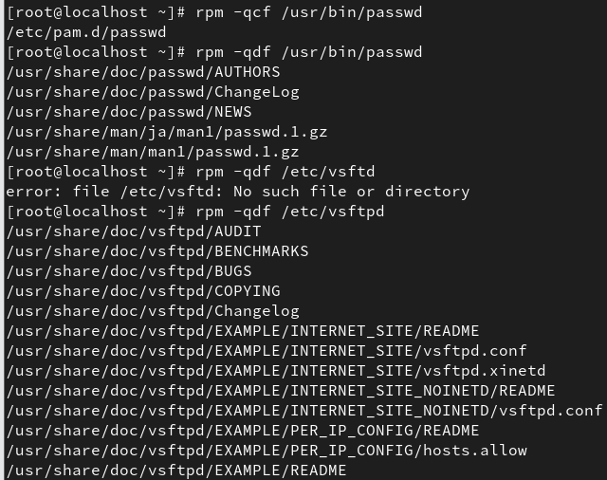

1. Remove the package using – rpm -evv or -evh packagename

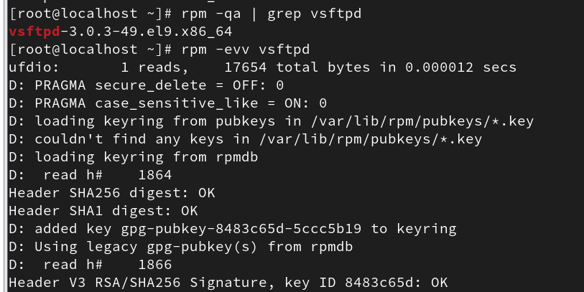

1. Remove the package without checking for dependencies
   1. rpm -ev –nodeps packagename (nodeps option should be used very carefully as it will remove the package even if it is a dependency for other packages)
2. Query Format – display columns
   1. rpm -qa –queryformat ‘%{name}---%{release}---%{version}\n’ | more

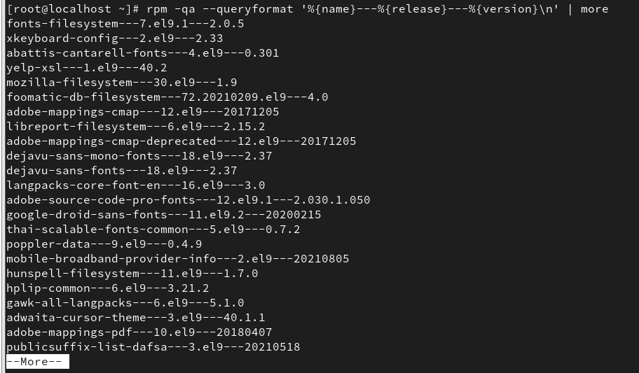

* 1. rpm -qa –queryformat ‘%{name}---%{size}---%{release}\n’ | more

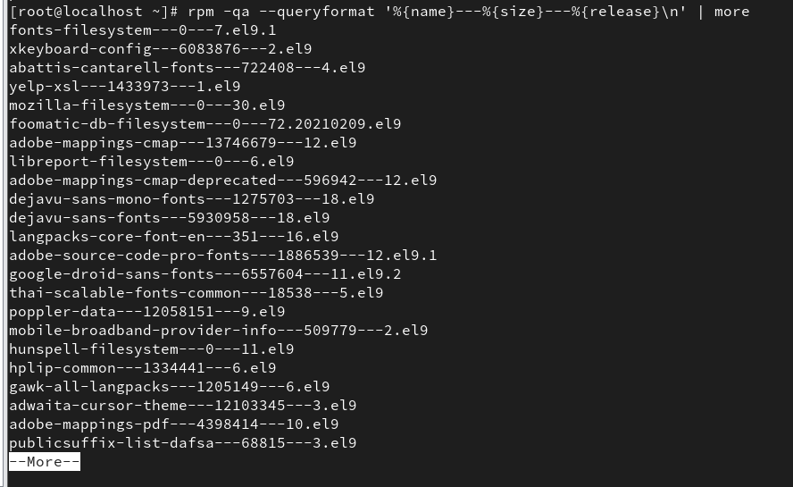

* 1. rpm -qa passwd –queryformat ‘%{name}---%{size}---%{release}\n’



* 1. rpm -qa acl –queryformat ‘%{name}---%{size}---%{release}\n’



2